

This is to certify that

___________________________________
Attended the
Infection Prevention Control Ireland Annual National Conference

Infection Prevention & Control for safer care

“Small Steps Lead to Big Changes”

Venue
Crowne Plaza Hotel Northwood Park, Santry, Dublin 9

Date
Friday 3rd May 2024

Signed by:
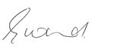
__________________
Emer Ward
IPC Ireland Chairperson

